Research Connections & Communication

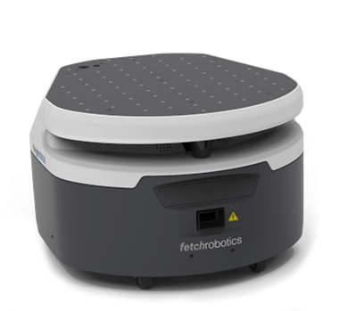

Fetch Robotics, [Freight Base](https://fetchrobotics.com/robotics-platforms/freight-base/)

## Hardware connections wired:

2x USB, 2x Ethernet, RS-45

## Hardware connections wireless:

Wi-Fi: 802.11ABGN and 802.15.1

## Software (operating system):

Ubuntu Linux LTS, Robot Operating System (ROS)

## Control options:

*Not specified*

# OTTO Motors, [OTTO 100](https://ottomotors.com/amrs)

## Hardware connections wired:

2x USB 3.0, 1x Ethernet POE, 16x DIO, RS-232

## Hardware connections wireless:

Wi-Fi: 802.11ABGNAC, 5 Ghz

## Software (operating system):

*Not specified*

## Control options:

OTTO Fleet Manager™

OTTO Industrial API

# PAL Robotics - [TIAGo Base](https://pal-robotics.com/robots/tiago-base/)

## Hardware connections wired:

I/O, CAN

## Hardware connections wireless:

Wi-Fi, Bluetooth

## Software (operating system):

Ubuntu LTS[, Robot Operating System (ROS)](http://wiki.ros.org/Robots/TIAGo-base)

## Control options:

Web GUI

RESTful API

# Waypoint Robotics, [Vector™](https://waypointrobotics.com/vector-robotic-mobility-platform/)

## Hardware connections wired:

USB, Ethernet

## Hardware connections wireless:

*Not specified*

## Software (operating system):

Robot Operating System (ROS)

## Control options:

*Not specified*

## Clearpath, [DINGO](https://clearpathrobotics.com/dingo-indoor-mobile-robot/)

## Hardware connections wired:

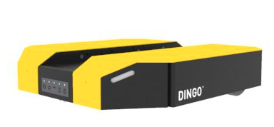USB 3.0, Ethernet, RS-232

## Hardware connections wireless:

*Not specified*

## Software (operating system):

Robot Operating System (ROS)

## Control options:

ROS Kinetic

MoveIt!

ROS ARK API

# Geek+ - [M100](https://www.geekplus.com/product-2/moving)

## Hardware connections wired:

*Not specified*

## Hardware connections wireless:

*Not specified*

## Software (operating system):

*Not specified*

## Control options:

*Not specified*

*Geek+ is only offering complete solutions for warehouse automation. No technical information of the AGVs was found.*

## Lowpad, [M](https://www.lowpad.com/lowpad-family/lowpad-m)

## Hardware connections wired:

?

## Hardware connections wireless:

?

## Software (operating system):

?

## Control options:

?

## Oppent EVO, [base™](https://www.oppent-evo.com/en/prodotto/evo-base-2/)

## Hardware connections wired:

?

## Hardware connections wireless:

?

## Software (operating system):

?

## Control options:

?